# **Graphic Era Deemed to be University**



**Department Of Computer Science and Engineering**

**Project work**

**On**

**Online Course Registration System**

**Submitted by – Under Guidance of –**

**Name : Md Amanullah Miss. Sarishma Dangi**

**Class : B Tech CSE**

**Section : I**

**University Roll : 2016852**

**Class ROLL : 48**



### ACKNOWLEDGEMENT

### 

I would like to take this opportunity to express my gratitude to entire faculty at Department of Computer Science and Information Technology, Graphic Era Deemed to be University, Dehradun who evaluated the project from time to time and gave me valuable suggestions as to how to improve the project.

I am grateful to **Miss Sarishma Dangi** of Graphic Era Deemed to be University, Dehradun, for his supervision, encouragement, inspiration and guidance. Working under her is being an enriched experience.

In all, I found congenial work environment in Graphic Era University, Dehradun and this project completion will mark a new beginning for me in the coming days.

I am highly indebted to Graphic Era University for providing me the required infrastructure and facilities to accomplish the given task.

**MD AMANULLAH**

**B.TECH CSE**

**2020 - 2024**

**Graphic Era University**

**Problem Statement :**

**Online Course Registration System.**

**Development Environment :**

• **Net Beans IDE**

• **MySQL Workbench**

**Languages used :-**

**JAVA LANGUAGE (JAVA 17.0.1)**

**SQL (STRUCTURED QUERY LANGUAGE )**

**Framework used:-**

* **Swing Framework**
* **JAVAFX Framework**
* **MySQL for Data Management.**

**JAVA LANGUAGE (JAVA 17.0.1) :-**

Java is a programming language and computing platform first released by Sun Microsystems in 1995. It has evolved from humble beginnings to power a large share of today’s digital world, by providing the reliable platform upon which many services and applications are built. New, innovative products and digital services designed for the future continue to rely on Java, as well.

While most modern Java applications combine the Java runtime and application together, there are still many applications and even some websites that will not function unless you have a desktop Java installed. Java.com, this website, is intended for consumers who may still require Java for their desktop applications – specifically applications targeting Java 8. Developers as well as users that would like to learn Java programming should visit the [dev.java](https://dev.java/) website instead and business users should visit [oracle.com/java](https://www.oracle.com/java/) for more information.

**Swing Framework :-**

**Swing** is a [GUI](https://en.wikipedia.org/wiki/Graphical_user_interface) [widget toolkit](https://en.wikipedia.org/wiki/Widget_toolkit) for [Java.](https://en.wikipedia.org/wiki/Java_(programming_language)) It is part of [Oracle'](https://en.wikipedia.org/wiki/Oracle_Corporation)s [Java Foundation Classes](https://en.wikipedia.org/wiki/Java_Foundation_Classes) (JFC) – an [API](https://en.wikipedia.org/wiki/Application_programming_interface) for providing a [graphical user interface](https://en.wikipedia.org/wiki/Graphical_user_interface) (GUI) for Java programs.

Swing was developed to provide a more sophisticated set of GUI [components](https://en.wikipedia.org/wiki/Software_component) than the earlier [Abstract Window Toolkit (AWT).](https://en.wikipedia.org/wiki/Abstract_Window_Toolkit) Swing provides a [look and feel](https://en.wikipedia.org/wiki/Look_and_feel) that emulates the look and feel of several platforms, and also supports a [pluggable look and feel](https://en.wikipedia.org/wiki/Pluggable_look_and_feel) that allows applications to have a look and feel unrelated to the underlying platform. It has more powerful and flexible components than AWT. In addition to familiar components such as buttons, check boxes and labels, Swing provides several advanced components such as tabbed panel, scroll panes, trees, tables, and lists.[[2]](https://en.wikipedia.org/wiki/Swing_(Java)#cite_note-2)

Unlike AWT components, Swing components are not implemented by platform-specific code. Instead, they are written entirely in Java and therefore are platform-independent.

## JAVA FX Framework :-

## JavaFX is a Java library that is used to develop Desktop applications as well as Rich Internet Applications (RIA). The applications built in JavaFX, can run on multiple platforms including Web, Mobile and Desktops.

## Our JavaFX tutorial includes all topics of JavaFX library such as Fundamentals, 2D Shapes, 3D Shapes, Effects, Animation, Text, Layouts, UI Controls, Transformations, Charts, JavaFX with CSS, JavaFX with Media etc.

## JavaFX is intended to replace swing in Java applications as a GUI framework. However, It provides more functionalities than swing. Like Swing, JavaFX also provides its own components and doesn't depend upon the operating system. It is lightweight and hardware accelerated. It supports various operating systems including Windows, Linux and Mac OS.

### MySQL Framework :-

MySQL is a relational database management system based on the Structured Query Language, which is the popular language for accessing and managing the records in the database. MySQL is open-source and free software under the GNU license. It is supported by **Oracle Company**.

Our MySQL tutorial includes all topics of MySQL database that provides for how to manage database and to manipulate data with the help of various SQL queries. These queries are: insert records, update records, delete records, select records, create tables, drop tables, etc. There are also given MySQL interview questions to help you better understand the MySQL database.

**Online Course Registration System**

## Introduction

Online Course Registration System is Web-based registration software that helps you to register courses online. It is ideal for schools, educational camps, corporate training programs, and online training programs. It also provides time to time current status information related to courses. It can help for the student need to register by giving necessary details, for the desired course.

##### **About the Project:**

The project objective will be focused on developing an online course registration to ensure the effectiveness of the flow of registration. Moreover the system will offer a complete management system that integrated with the online course registration to help the stakeholder for maintaining the flow process of the course.

##### 

##### **Online Course Registration System Modules**

**This Project Divided into six modules**

* **Main**
* **Admin**
* **Admin Login**
* **Student**
* **Student Login**
* **Student Signup**
* **Registered Student Details**

**Main –** Main module contain the offered course name (where the admin and student can only see the name of the course), login and signup button for student, login and signup button for admin and the about button for knowing the details of university.



**Admin –** Admin module contain the course details (where he can see the details of the course and also have right to update it ), registered student details(where they will able to see the details of registered student details ) and the courses which are available. Admin will able to create the courses for registration. They will able see the records of registered student.

**Student –**Student module contain the course details (where he can see the details of the course) , available course details(where they will able to see the available course for registration ) and the courses which are available. Admin will able to create the courses for registration. They will able see the records of registered student .

**Admin Login/Signup–**Admin Login/Signup module contain the login area for the admin so that everyone can not able to access the course details or update it.

And also the signup area for them if any new admin come they will able to create their own username and password.

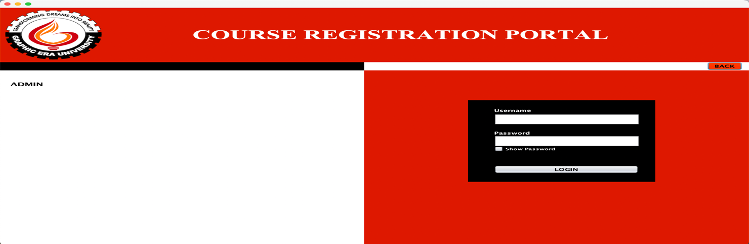

**Student Login/Signup –** Student Login/ module contain the login area for the student so that only registered student can able to register for the course and access the course details. If the student have not account they can go to signup to register themselves and registered its own username and password.

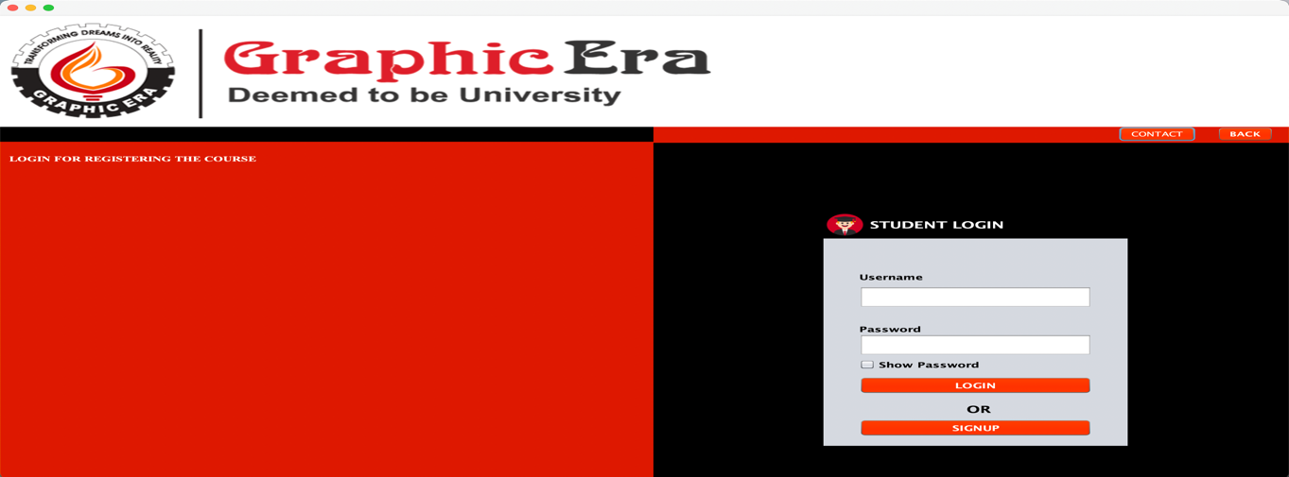

**Registered Student Details–** Admin will only able to access it where they can able to get details of registered student and also the course he had registerd.

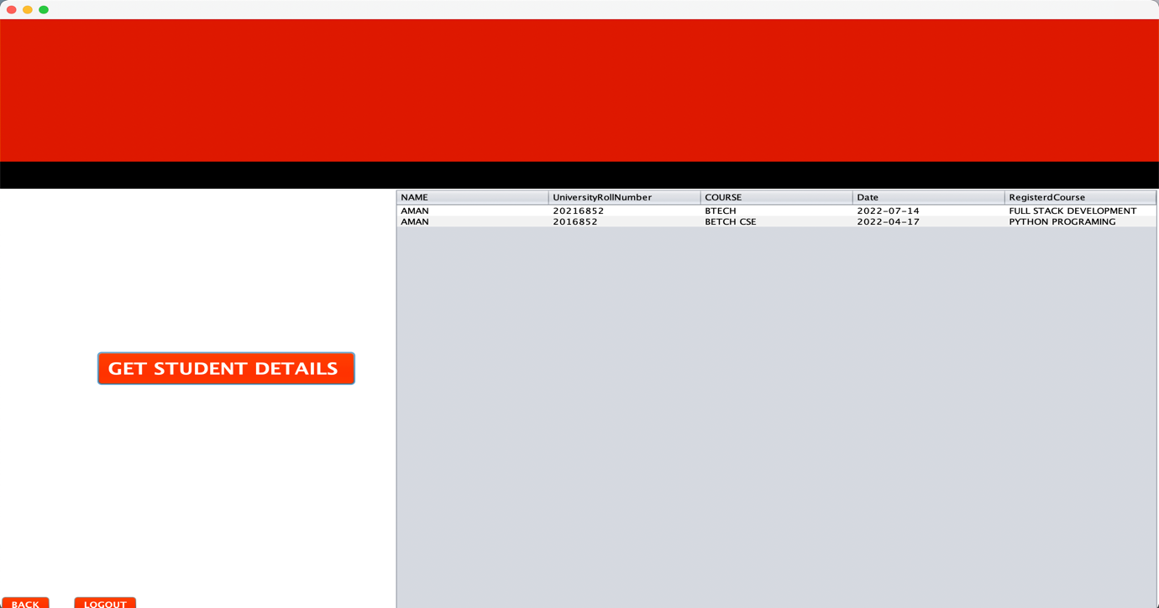

**ADVANTAGE OF ONLINE COURSE REGISTRATION SYSTEM**

* Convenience and speed
* Immediate confirmation
* Online registration systems are secure
* Real Time update
* Eco Friendly

## Conclusion

Besides, using an online registration system is a great way of showing the respective event organizer’s credibility and future-focused approach. Online registration systems are becoming the norm in the society due to all these good reasons.

**PROJECT LINK**

You can watch the demonstration video using this link

* <https://drive.google.com/drive/folders/1u67DSejk9UqhiJl2fqliyek37tEak7mu?usp=sharing>

You can see the codes using this link

* <https://github.com/amanullahmd12/onlineCourseRegistrationSystem>

**BIBLIOGRAPHY**

**References :**

**For MySQL**

* <https://docs.oracle.com/cd/E11882_01/appdev.112/e12137/getconn.htm#TDPJD127>
* <https://www.javatpoint.com/mysql-tutorial>
* <http://www.mysqltutorial.org/>

**For JAVA**

* <https://stackoverflow.com/questions/7358775/java-gui-frameworks-what-to-choose-swing-swt-awt-swingx-jgoodies-javafx>
* [https://www.udemy.com/course/java-se-programming/learn/lecture/18566726 - overview](https://www.udemy.com/course/java-se-programming/learn/lecture/18566726#overview)
* <https://www.youtube.com/>